Literacy Barriers
(Including Dyslexia, Verbal Stress)

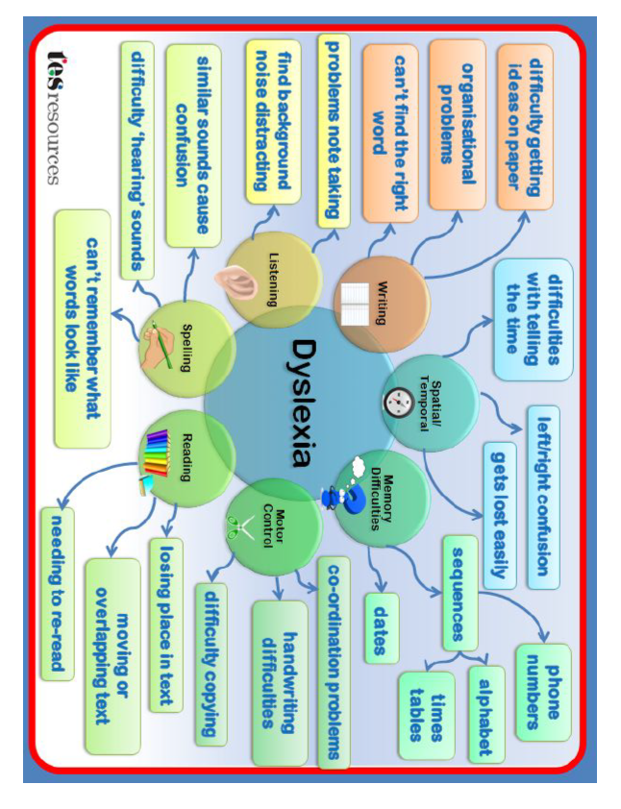

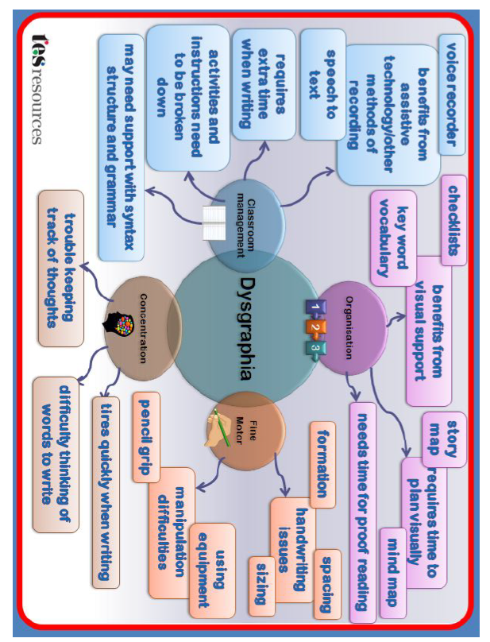

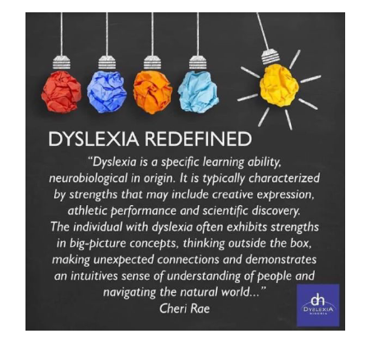

If you feel like a child is showing dyslexic tendencies, please talk to the SENCO. We have a dyslexia screening tool which, although doesn’t diagnoses dyslexia, can point to difficulties and strategies to implement.
A dyslexia diagnosis can only be given by a dyslexia assessor. Some opticians conduct them and I also have some other contacts.
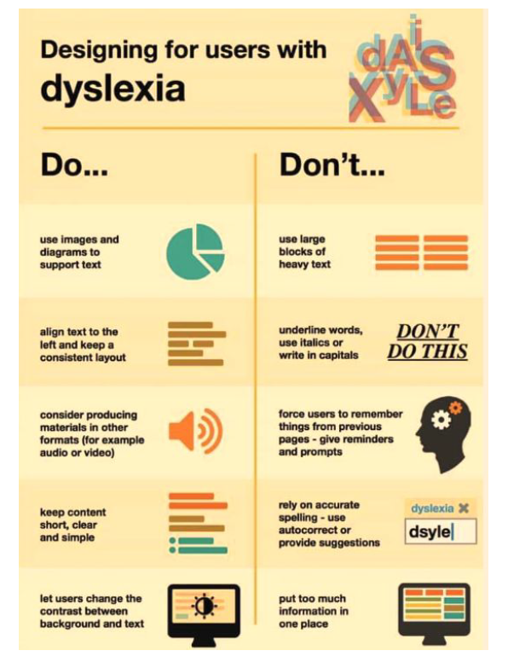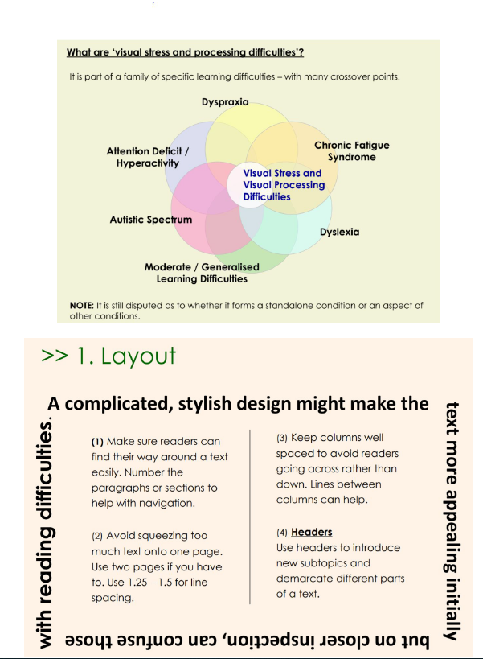

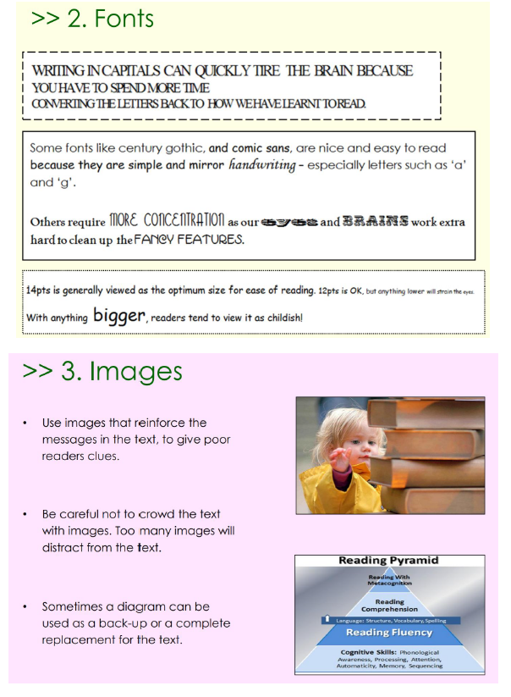

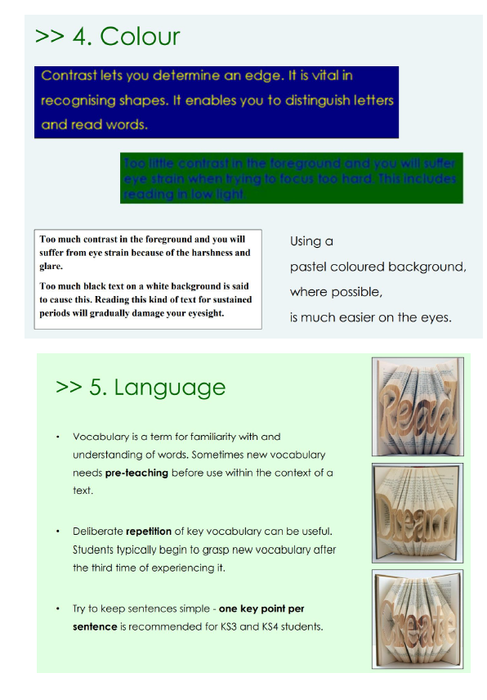

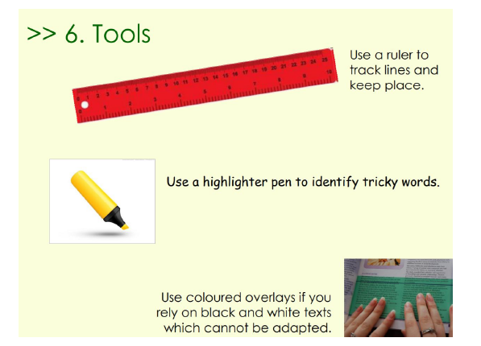

If you feel like a child in your class would benefit from a coloured overlay, please see Dannielle Wright who will complete an assessment on the child to find the most suitable coloured overlay (if required).

