## 

British Values

29th March – 4th April 2021

**Individual Liberty**

BT are offering red telephone boxes to communities for £1. This offer gives people a choice of whether to have them removed or reuse them for a different purpose. In this way, the iconic red telephone boxes can be preserved as a symbol of British culture.



29th March 2021

**UN Rights of a Child**

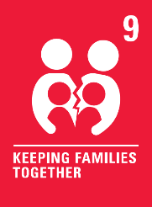

Communicating by phone can be a good way to make sure that we can remain in contact with our families when we are unable to be together.